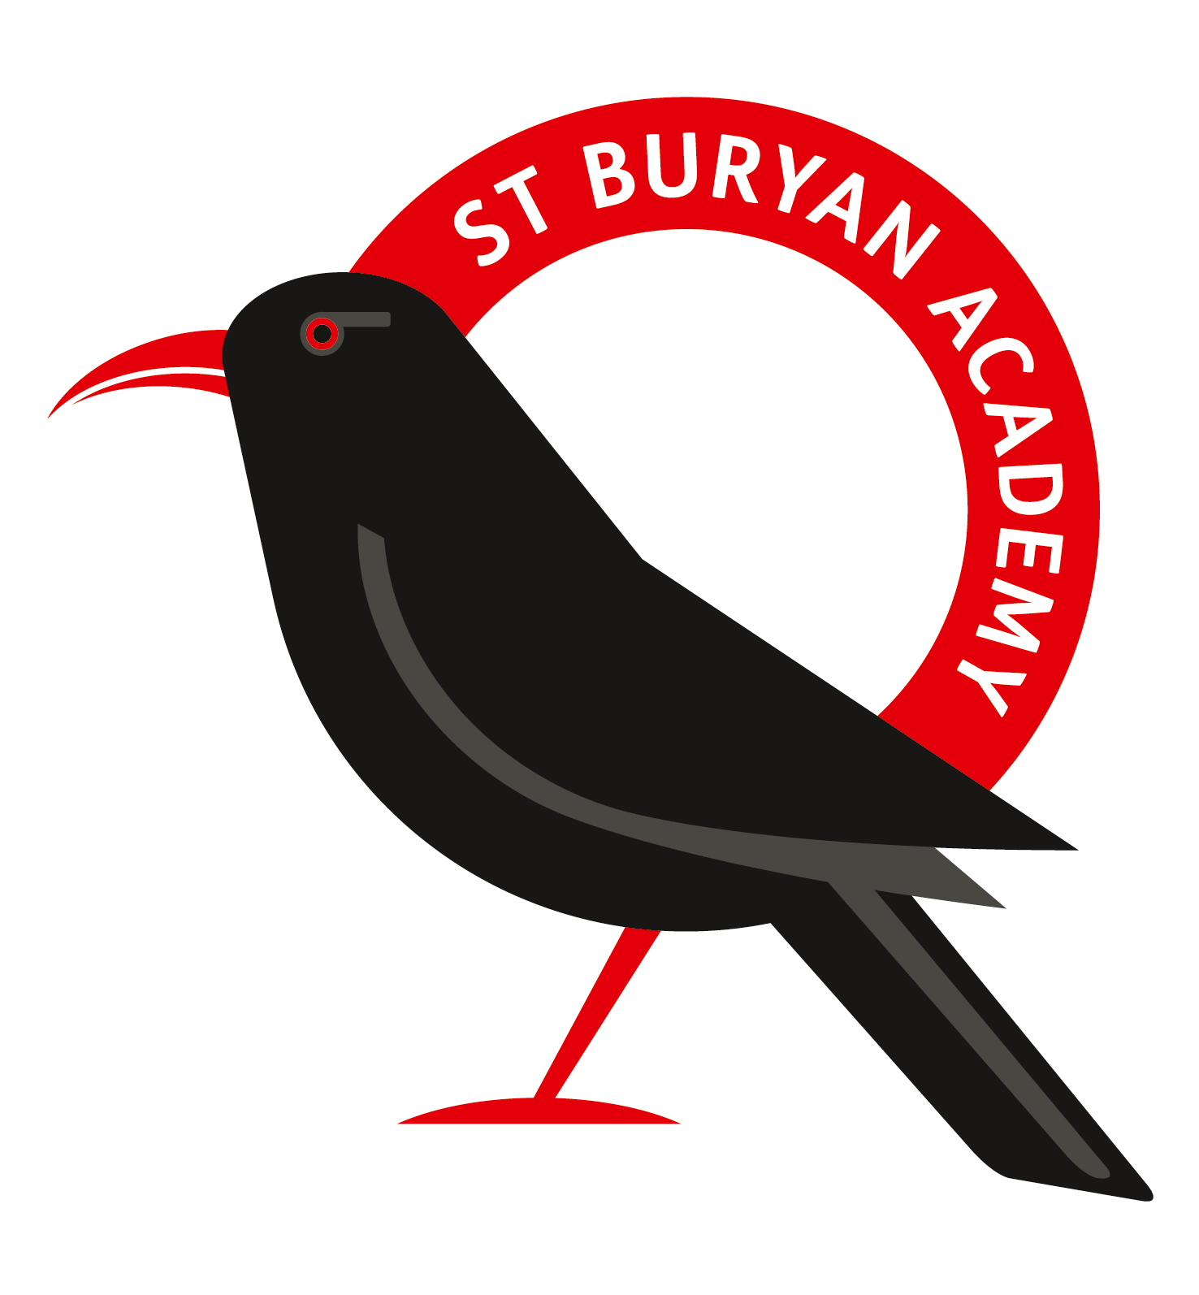

Re: Government Attendance Expectations

Friday 20th September 2024

Dear Parent/Carer

Here at St Buryan Primary School, we recognise that there are occasions when it is appropriate to authorise an absence, such as when a pupil is genuinely too ill to attend school.

However, the Government does not support parents taking children out of school unless the school agrees this is appropriate under ‘*exceptional circumstances*’. Any request for leave should be made in writing to the Headteacher using the school’s ‘*Leave of Absence Exceptional Circumstances’* request form.

*If your child is absent from school without authorisation, you will be committing an offence under the Education Act 1996. We may submit a request to Cornwall Council for a Penalty Notice to be issued, in accordance with Sections 444A and 444B of the said Act. Penalty Notices are issued per liable parent, per child and each carry a fine of £80 if paid within 21 days or £160 if paid after this but within 28 days.*

*If your child is further absent from school without authorisation within any 3-year period, you will be committing a further offence under the Education Act 1996. We may submit a request to Cornwall Council for a Penalty Notice to be issued, in accordance with Sections 444A and 444B of the said Act. Penalty Notices for a second offence are issued per liable parent, per child and each carry a fine of £160, payable within 28 days. Importantly, fines per parent will be capped to two fines within any three-year period. Once this limit has been reached, other action such as a parenting order or prosecution will be considered.*

*Failure to pay the Penalty Notice may also result in legal action. If you are prosecuted and attend court because your child has not been attending school, you could get a fine of up to £2,500. Cornwall Council may also apply for the costs incurred in taking the matter to Court, including legal costs.*

*Absence not authorised by the school may also result in a prosecution in the Magistrates’ Court under Section 444(1) or Section 444(1A) of the Education Act 1996, leading to a fine of up to £2,500 and/or a custodial sentence. Again, Cornwall Council may also apply for the costs incurred in taking the matter to Court, including legal costs.*

*Money raised from fines is only used by the local authority to cover the costs of administering the system, and to fund attendance support. Any extra money is returned to the government.*

‘Parent’ as set out in Section 576 of the Education Act 1996, defines parent to include: natural parents, whether they are married or not; any person or body who has parental responsibility for a child (as defined by the Children Act 1989) and; any person who, although not a natural parent, has care of a child. Having care of a child means a person with whom a child lives and who looks after a child, irrespective of what their relationship is with said child.

You are welcome to contact the school to discuss any concerns you may have regarding this or if you feel you would like advice or support in helping your child attend more regularly. St Buryan Primary School is committed to enabling every child to reach their full potential and aims to work with parents to ensure this can be achieved.

Yours sincerely

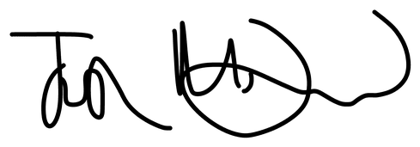

Mr Josh McDonald

Headteacher