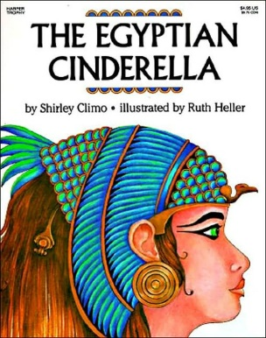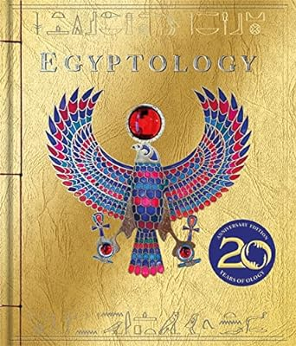

**RE:** Unit 1.8, What makes some places sacred to believers?

Unit 1.9, How should we care for others and the world, and why does it matter?

**SPaG:** Year 2 – expanded noun phrases, subordination, co-ordination and commas in a list.

Year 3 – using nouns and pronouns for cohesion, punctuation speech and fronted adverbials.

**Geography & History**

In this unit, children learn about how early civilisation started within Egypt. They shall discover how the upper and lower kingdoms joined together to create the Ancient Egypt of the Old Kingdom. The children will compare the Egyptian time period to Neolithic in Britain, to find out what was happening at the same time and how these two civilisations compared. The children will then discover all about the Egyptian gods, what Ancient Egyptians believed about the afterlife, how the pyramids were built and who the greatest pharaoh was in all of Egypt’s history.

**‘The Ancient Egyptians’**

***What were the greatest achievements of the Ancient Egyptians?***

**Art & Design Technology**

Textiles – pouches Y2 unit.

Textiles – Egyptian collars Y3 unit.

Painting and mixed media: Life in colour.

Craft and design: Ancient Egyptian scrolls

**Writing:**

Whole school writing unit – poetry unit on ‘The Lost Words’.

Narrative writing unit based on ‘The Egyptian Cinderella’.

Fact Files based on Egyptian Gods and Goddesses and Pharaohs.

Explanation unit linked to ‘How were the dead mummified in Ancient Egypt?’

**Science:**

We will learn about different seeds and bulbs. They will learn about plants we can eat and begin to gather seeds. They will also look at what plants need to grow and what they need to continue to grow and stay healthy. They will identify and describe the functions of the different parts of plants. They will explore what plants need for life and growth. They will learn about water transportation.

**Mathematics:**

**Year 2**

Money – 2-week block

Multiplication and Division – 5-week block

Length and Perimeter – 2-week block

Mass and Capacity – 3-week block

**Year 3**

Multiplication and division, part 2 – 3-week block

Length and Perimeter – 3-week block

Fractions, part 1 – 3-week block

Mass and Capacity – 3-week block

**Reading:**

**PE:**

**Football, Gymnastics, Swimming and Forest School.**

