**Religious Education**

Who is Jewish and how do they live?

**PSHE –** Being me in my world.

**Art** – Tell a story through drawing. Painting mixed media, life in colour.

**Music** – exploring simple patterns and focus upon dynamics and tempo.

**Geography –** thechildren will use atlases and globes to discover about the world, including the seven continents and five oceans, the countries, capital cities and surrounding seas of the UK and the equator and poles. Children will develop fieldwork and map skills creating maps of the school and their local area. Children will learn the geographical human and physical features of Tulum in Mexico and compare them to the geographical features of their own local area.

**HISTORY:**

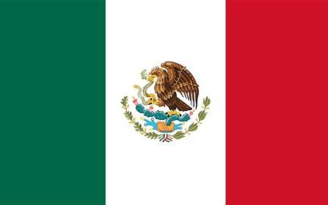

**Mexico V Home**

***What makes Mexico magnificent?***

**PE & Outdoor Learning**

Tuesday – Hockey (first half term) then netball (2nd half term).

We will be swimming every Thursday.

**Writing**

This term we will focus on the following areas:

* Sentence structure
* Punctuation and Grammar
* Narrative with a focus on setting and character description
* Persuasive writing – holiday brochure advert for either ‘Mexico or Home’

Reading will be taught through daily guided reading sessions through our class novel ‘The Queen’s Nose’ and a range of other texts to help us secure our VIPERS skills.

SPAG - spellings will be taught in class and sent home to reinforce. Informal spelling quizzes will be used as assessment.

**Science**

Animals including Humans - identify that animals, including humans, need the right types and amount of nutrition, and that they cannot make their own food; they get nutrition from what they eat. Plus, identify that humans and some other animals have skeletons and muscles for support, protection and movement

**Mathematics:**

Place value – understand the value of each digit, compare and order numbers.

Addition and subtraction – use addition and subtraction facts to 20 and derive and use related facts up to 100. Add and subtract both mental and written methods.

Year 2 only -Shape – describe 2d and 3d shapes using mathematical vocabulary.

Year 3 only - Multiplication and division – learnt eh 3, 4 and 8 times tables. Use multiplication facts to solve written and mental problems.

**READING:**

