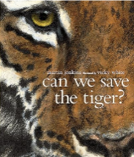St. Buryan Academy Termly Overview Class: Porthcurno Term: Summer 2024

**Maths**

We will start this term by revisiting the objective taught so far and focus on problem solving and reasoning linked to these. We will go on to cover properties of shape (including angles), converting units of measures and time, and volume.

Year 6 will also look at algebra and ratio.

Times Tables will be a focus for those who do not yet have a secure understanding.

**Reading/ Class Novel**

Our class novel this term is ‘The Explorer’ by Katherine Rundell

This novel is set in the Amazon and will help the children get a real feel for the rainforest.

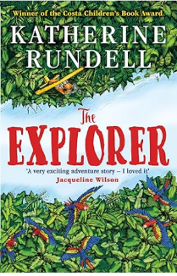

**Rivers and Rainforests**

***Why is water so important?***

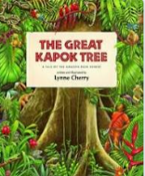

**Geography**

Geography will be the main focus for this topic. We will focus on the Amazon rainforest in South America and make comparisons with our own locality as well as wider Britain and Europe.

We will learn about climate zones, biomes and vegetation belts as well as the distribution of natural resources including food as well as learning about the water cycle.

**English**

This term our writing will start with a unit based on the picture book ‘Can We Save the Tiger?’ where the children will explore the extinction of animals and write a letter, an explanation, a persuasive poster, a persuasive speech, a poem and finish with a discussion text.

We will then use the picture book ‘The Great Kapok Tree’ to write persuasive letters and a narrative.

We will continue to have a focus on spellings, punctuation and grammar alongside our English lessons.

**Science**

**Animals, including humans -** describe the changes as humans develop to old age

**Living things and their habitat -** describe the differences in the life cycles of a mammal, an amphibian, an insect and a bird

* describe the life process of reproduction in some plants and animals

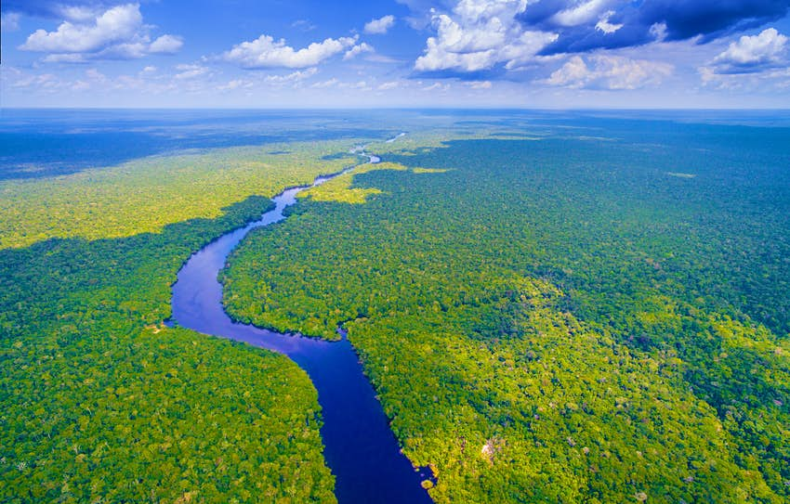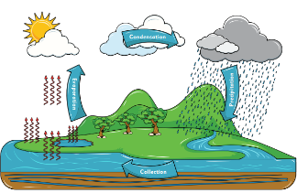

**PE:** Cricket and Athletics

**Music:** Singing with a focus on songs from history (WWII link in preparation for Feast Concert) Music from that era.

**Computing:** Coding using micro:bit programmable devices

**Art/ DT:** Artist study: Henri Rousseau and John Dyer

Food technology – creating a dish linked to South America.

**RE:**

S1: For Christians, what kind of king was Jesus?

S2: Why do some people believe in God and some people not?

**PSHE:**

This terms focus will be on ‘relationships’ and ‘changing me’