**MATHEMATICS:**

Reception:

* Match, sort and compare.
* Measuring and patterns.
* Numbers 0-5; subitising, representing numbers, number composition, number bonds.
* 2D shapes: names and properties

Year 1:

* Place value of numbers to 20: counting; representing; comparing; ordering; finding one more and one less; using number lines.
* Addition and subtraction of numbers to 20: using part-whole model; finding a part; writing number sentences; fact families; number bonds; comparing number sentences; problem solving using money.
* Place value of numbers to 50: representing numbers; comparing; counting in 2s,5s and 10s; grouping; making doubles.

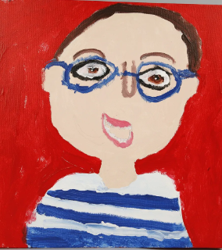

**WRITING:**

Here are some examples of writing inspiration for our topic:

‘Family and me’ story:

* labels and name writing;

* description writing;

* writing a family tree;

* sequencing events;

‘What makes me, a Me?’ story:

* writing statements, commands, and questions;

* writing posters;

* writing their own story.

We will also look at poetry, reading with expression and reciting it.

**READING:**

Daily story time- range of books connected to the topic as well as those linked to children’s interests.

Individual books sent home.

Children are invited to choose books form the Library selection at any time and we encourage children to change them independently. Please enjoy sharing those at home.

**SPaG:**

Looking at sentence structure, including capital letters and full stops.

Introduce technical vocabulary, such as nouns.

Daily phonics lessons.

Practising reading and writing of tricky words.

**All about ourselves.**

**What makes me, me?**

HISTORY? GEOGRAPHY:

Seasonal changes and how the weather affects us.

In history we will look at famous individuals and their stories.

We will focus on Famous Explorers.

Guy Fawkes and the Gunpowder Plot.

Remembrance Sunday.

**SCIENCE:** Animals including Humans

What is this animal called?

How are animals different?

Do all animals eat the same food?

What are our body parts called?

What are senses?

Are all humans the same?

RE: * Hinduism

* What do Christians believe God is like?

* Why does Christmas matter to Christians?

Art/DT: Use a range of materials to design and make. Drawing, painting, mixing colours.

* MUSIC: Listening and responding to different styles of music
* Embedding foundations of the interrelated dimensions of music