**WRITING:**

Whole school writing unit based on ‘The Tin Forest’ – write descriptive sentences to describe a setting. Write a narrative based on the story.

Writing linked to our topic –

Diary writing linked to Samuel Pepys and newspaper reports recounting the devastation. descriptive settings

**READING:**

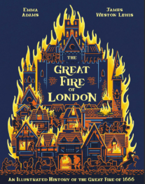 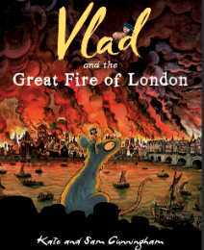

**Art / DT**

Design, construct, evaluate and burn wooden houses in the Tudor style.

Create mixed media artwork.

**HISTORY:** We will discover what London was like in 1666. They will make comparisons between then and the present day, discover what happened on the night of 2nd September 1666 when the Great Fire of London started, discuss why the fire spread quickly and how it was tackled. The children will be introduced to key historical individuals, such as Thomas Farriner, Samuel Pepys, King Charles II and Sir Christopher Wren and explore evidence, such as Samuel Pepys’ diary and objects left behind after the fire, to help them form opinions about what happened over 350 years ago.

**RE:** What do Hindus believe that God is like? What does it mean to be Hindu in Britain today?

**SCIENCE:**

We will learn about the structure of the human skeleton and how the muscles work alongside the skeleton to support and protect the human body. They will then look at how skeletons differ in different animals. Finally, children will look at nutrition and the importance of eating a healthy diet.

**MATHEMATICS:**

Year 2 blocks – Addition and Subtraction, Multiplication and Division, Length and Height and Statistics.

Year 3 blocks - Multiplication and Division, Length and perimeter, Fractions part 1, Mass and capacity and Fractions part 2.

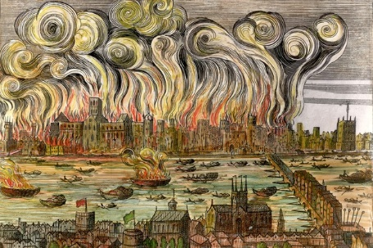

**The Great Fire of London**

***How did the ‘Great Fire’ change London?***

**Showcase: A great fire of our own wooden constructed homes.**

**PE:** On Tuesday, they will be playing rugby or gymnastics and swimming every Thursday.